MENTORNESS ARTICLE

TASK 1

MIP-ML-08

By: Mehul Ligade

ML in Marketing

**Introduction:**

In today's changing marketing landscape, firms are constantly looking for new ways to effectively contact and engage their target customers. With the introduction of machine learning (ML), marketing methods have experienced a fundamental shift. From individualized customer segmentation to bespoke recommendation systems and efficient marketing campaigns, machine learning algorithms are changing the way organizations connect with their customers. In this article, we look into the uses of machine learning in marketing, studying how it drives customer segmentation, recommendation systems, and marketing optimization techniques.

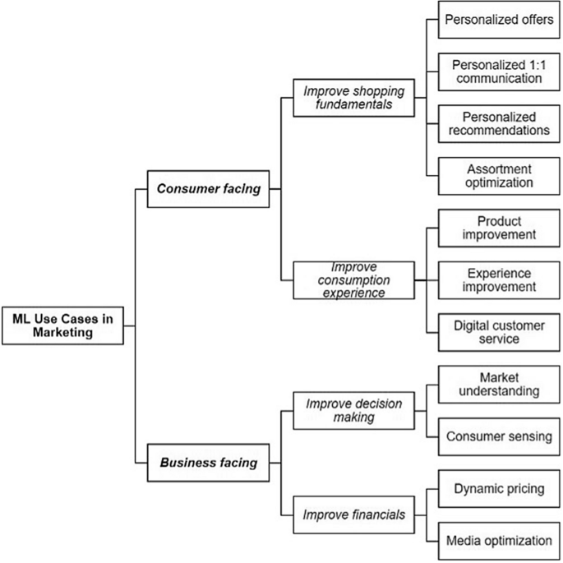

**Customer Segmentation:**

Historically, marketers used demographic data to divide consumers into broad categories. However, ML algorithms allow for a more nuanced approach by analysing large datasets to find detailed patterns and preferences among clients. Customers can be segmented based on their behaviour, tastes, and purchasing history using techniques such as clustering and classification in machine learning models.

For example, an e-commerce platform can use ML algorithms to divide users into groups with similar browsing and purchasing habits. Understanding the unique features of these categories allows marketers to adjust their messaging, promotions, and product offerings to each group, increasing engagement and conversions.

**Recommendation Systems:**

Personalized suggestions have grown common in today's digital ecosystem, affecting customer purchasing decisions across several platforms. ML-powered recommendation systems employ prior user activities, such as purchases, clicks, and preferences, to reliably forecast future desires.

Netflix, for example, uses ML algorithms to recommend material based on user viewing history, reviews, and genre interests. By constantly refining these recommendations based on user feedback and behaviour, Netflix improves customer satisfaction and retention, resulting in subscription income.

Similarly, e-commerce behemoths like Amazon use advanced recommendation algorithms to provide individualized product suggestions, resulting in higher sales and consumer loyalty. These systems serve consumers by offering relevant options, but they also allow firms to optimize cross-selling and upselling opportunities.

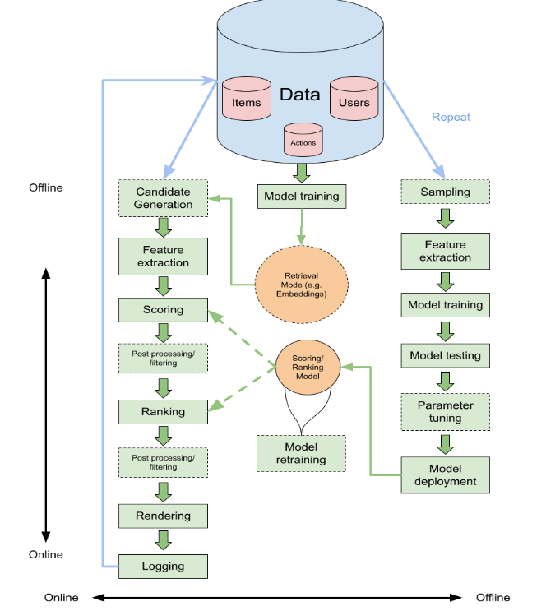

**Marketing Optimization:**

ML optimizes marketing campaigns by enabling data-driven decision-making and predictive analytics. Marketers can anticipate consumer behaviour and optimize different aspects of their campaigns, including ad targeting, messaging, and channel selection, using tools such as predictive modelling and sentiment analysis. Digital advertising platforms use machine learning algorithms to examine user data and anticipate which ad creatives will be most effective with specific audience demographics. Advertisers may boost campaign performance and conversion rates by dynamically altering ad placements and content in real time.

Furthermore, ML-powered attribution modelling allows marketers to precisely attribute conversions to the most important touchpoints along the customer journey. Understanding the proportional effects of multiple marketing channels and touchpoints allows firms to better manage marketing dollars and maximize ROI.

**Conclusion:**

Machine learning has emerged as a major change in the marketing industry, allowing firms to extract important insights from massive datasets and provide personalized experiences to customers. From consumer segmentation and recommendation systems to marketing optimization methods, machine learning algorithms drive efficiency, relevance, and profitability in marketing.

As businesses continue to leverage the potential of ML, the marketing environment will shift further, allowing for more precise targeting, increased consumer engagement, and, eventually, long-term growth. In an increasingly competitive environment, marketers can remain ahead of the curve and drive meaningful relationships with their audiences by adopting data-driven techniques and employing ML technologies.